Hyperboloid

Definition
# Source: AI Source: Provided by: [Data Path: Persons Table -> ID Column: 1, Name_En Column: Motasem Essam] -> From: [ChatGPT] on [7/25/2026]
A Hyperboloid is a three-dimensional quadric surface formed by a mathematical equation involving squared coordinates, with one or more negative squared terms.
It is characterized by curved surfaces that can form one connected part or two separate parts, depending on its type.
There are two main types of hyperboloids:
- Hyperboloid of One Sheet
- Hyperboloid of Two Sheets
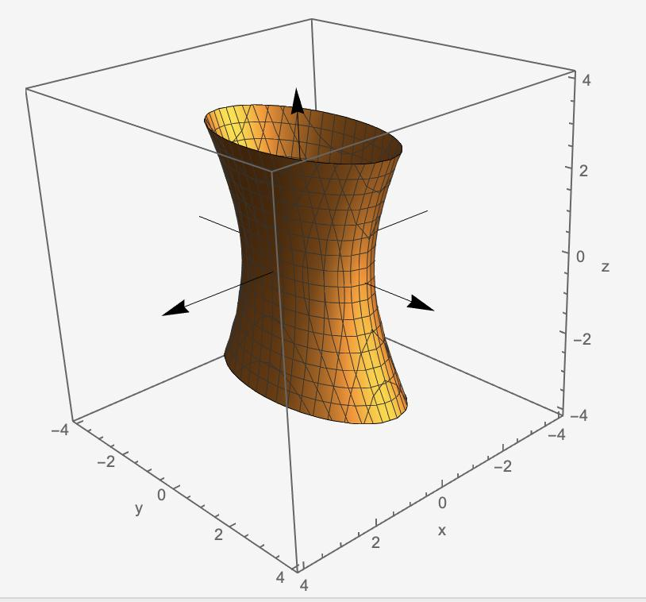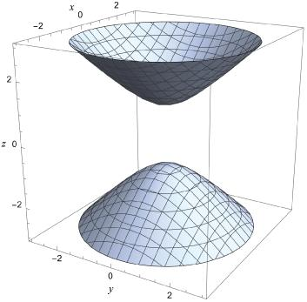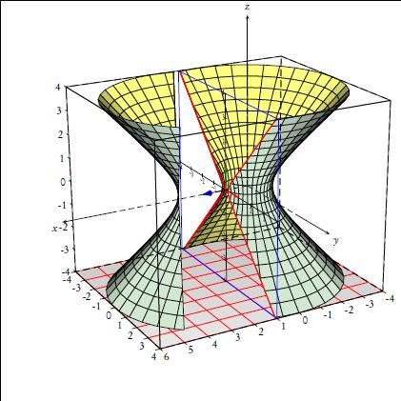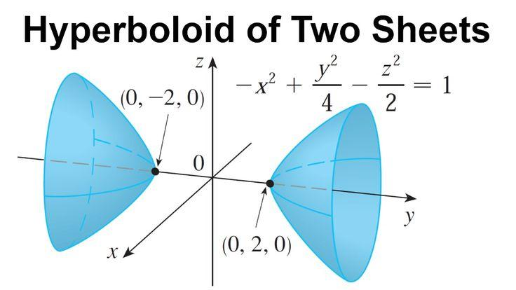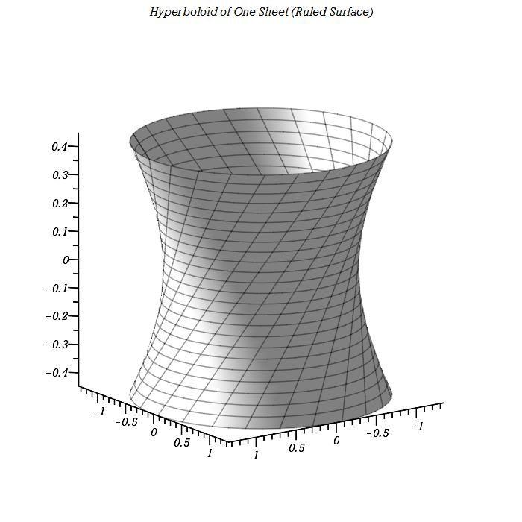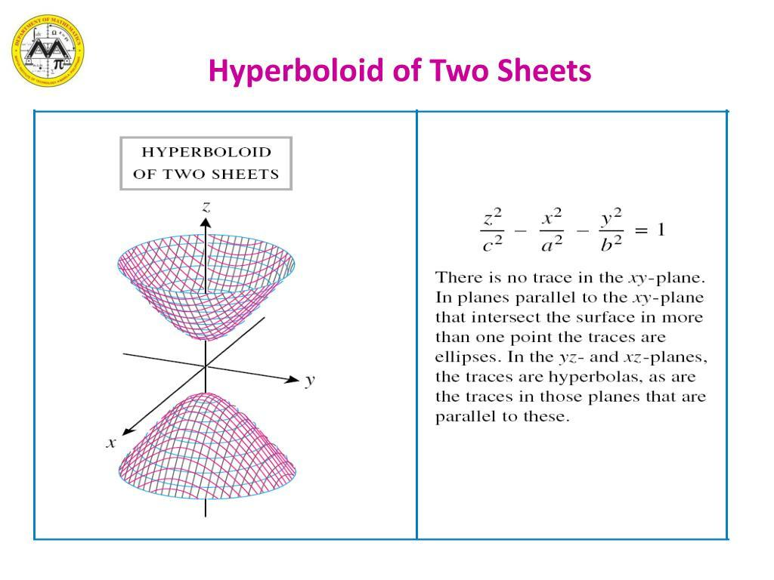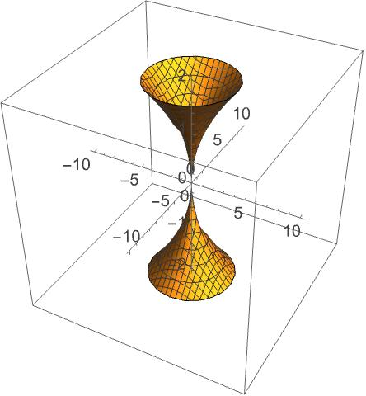

Simple Definition
# Source: AI Source: Provided by: [Data Path: Persons Table -> ID Column: 1, Name_En Column: Motasem Essam] -> From: [ChatGPT] on [7/25/2026]
A hyperboloid is a three-dimensional curved surface that resembles an hourglass, a cooling tower, or two separated bowl-like surfaces, depending on its type.

Geometric Structure
# Source: AI Source: Provided by: [Data Path: Persons Table -> ID Column: 1, Name_En Column: Motasem Essam] -> From: [ChatGPT] on [7/25/2026]
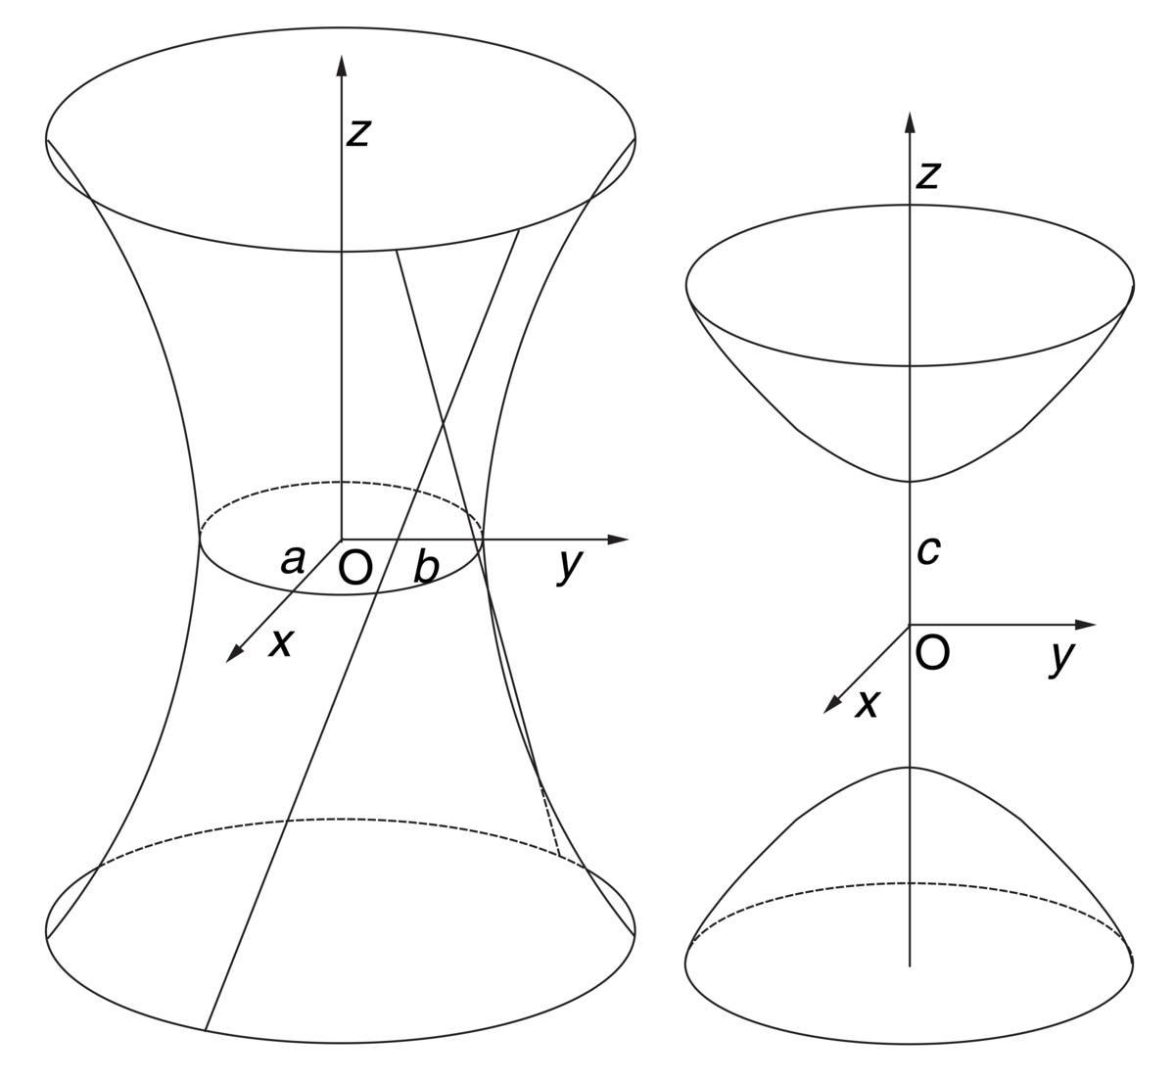
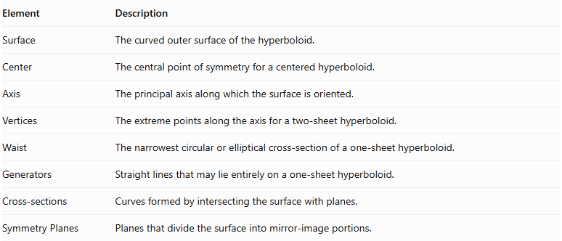
Element | Description
Surface | The curved outer surface of the hyperboloid.
Center | The central point of symmetry for a centered hyperboloid.
Axis | The principal axis along which the surface is oriented.
Vertices | The extreme points along the axis for a two-sheet hyperboloid.
Waist | The narrowest circular or elliptical cross-section of a one-sheet hyperboloid.
Generators | Straight lines that may lie entirely on a one-sheet hyperboloid.
Cross-sections | Curves formed by intersecting the surface with planes.
Symmetry Planes | Planes that divide the surface into mirror-image portions.

Center
# Source: AI Source: Provided by: [Data Path: Persons Table -> ID Column: 1, Name_En Column: Motasem Essam] -> From: [ChatGPT] on [7/25/2026]
The Center is the point of symmetry of a centered hyperboloid.
For the standard equations, the center is:
$$C=(0,0,0)$$

Axis
# Source: AI Source: Provided by: [Data Path: Persons Table -> ID Column: 1, Name_En Column: Motasem Essam] -> From: [ChatGPT] on [7/25/2026]
The Axis is the principal direction along which the hyperboloid is oriented.
A hyperboloid can have its principal axis along the x-axis, y-axis, or z-axis.

Vertices
# Source: AI Source: Provided by: [Data Path: Persons Table -> ID Column: 1, Name_En Column: Motasem Essam] -> From: [ChatGPT] on [7/25/2026]
Vertices are the extreme points of a hyperboloid of two sheets, located along its principal axis.
A hyperboloid of one sheet has no vertices in the usual sense.

Waist
# Source: AI Source: Provided by: [Data Path: Persons Table -> ID Column: 1, Name_En Column: Motasem Essam] -> From: [ChatGPT] on [7/25/2026]
The Waist is the smallest cross-section of a hyperboloid of one sheet.
For a circular hyperboloid, it is the smallest circular section.
For an elliptical hyperboloid, it is the smallest elliptical section.

Generators
# Source: AI Source: Provided by: [Data Path: Persons Table -> ID Column: 1, Name_En Column: Motasem Essam] -> From: [ChatGPT] on [7/25/2026]
Generators are straight lines that lie entirely on a ruled surface.
Both types of hyperboloid are ruled surfaces, meaning they can be formed by families of straight lines.

Main Classification
# Source: AI Source: Provided by: [Data Path: Persons Table -> ID Column: 1, Name_En Column: Motasem Essam] -> From: [ChatGPT] on [7/25/2026]
Hyperboloids are divided into two principal types according to the number of connected surface components.
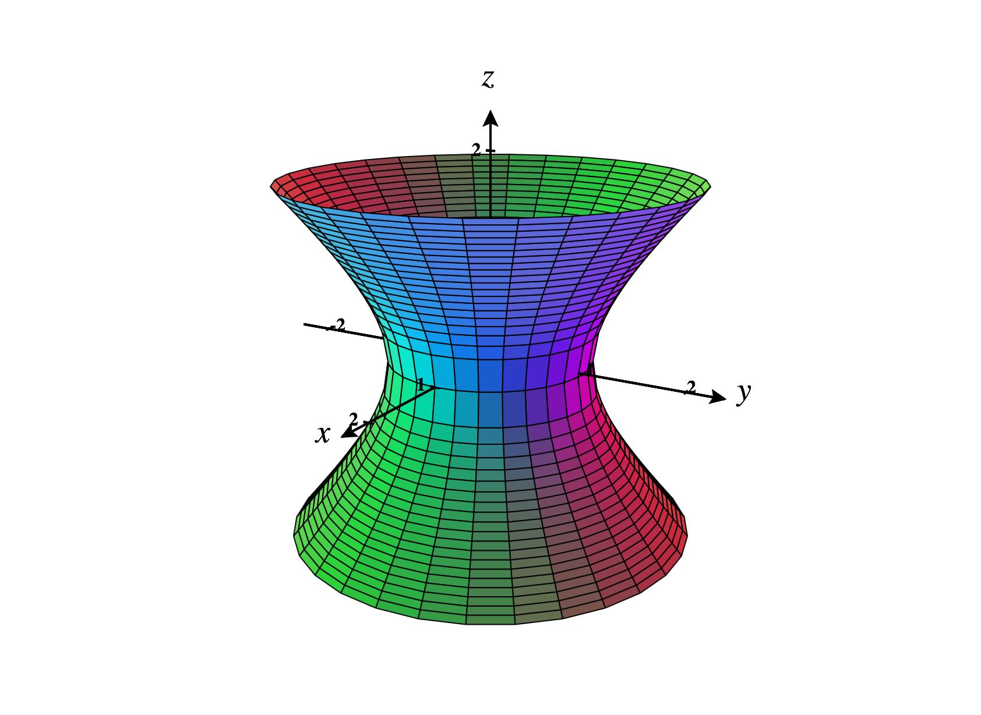

Hyperboloid of One Sheet
# Source: AI Source: Provided by: [Data Path: Persons Table -> ID Column: 1, Name_En Column: Motasem Essam] -> From: [ChatGPT] on [7/25/2026]
A single continuous connected surface with an hourglass-like shape. It narrows at the center and expands toward both ends.
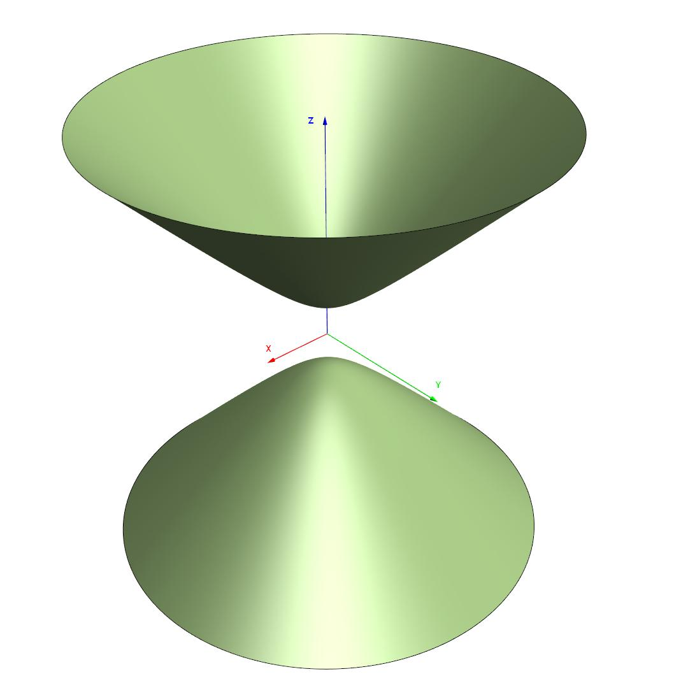

Hyperboloid of Two Sheets
# Source: AI Source: Provided by: [Data Path: Persons Table -> ID Column: 1, Name_En Column: Motasem Essam] -> From: [ChatGPT] on [7/25/2026]
Two separate connected surface components positioned on opposite sides of the center along the principal axis.

Mathematical Equations

Standard Equation of a Hyperboloid of One Sheet
# Source: AI Source: Provided by: [Data Path: Persons Table -> ID Column: 1, Name_En Column: Motasem Essam] -> From: [ChatGPT] on [7/25/2026]
When the principal axis is the z-axis:
$$\boxed{\frac{x^{2}}{a^{2}}+\frac{y^{2}}{b^{2}}-\frac{z^{2}}{c^{2}}=1}$$
Where:
- $a,b,c$ are positive scale parameters.
- The center is $C=(0,0,0)$.
- The principal axis is the z-axis.

Standard Equation of a Hyperboloid of Two Sheets
# Source: AI Source: Provided by: [Data Path: Persons Table -> ID Column: 1, Name_En Column: Motasem Essam] -> From: [ChatGPT] on [7/25/2026]
When the principal axis is the z-axis:
$$\boxed{\frac{z^{2}}{c^{2}}-\frac{x^{2}}{a^{2}}-\frac{y^{2}}{b^{2}}=1}$$
Where:
- $a,b,c$ are positive scale parameters.
- The center is $C=(0,0,0)$.
- The principal axis is the z-axis.
- The vertices are $(0,0,c)$ and $(0,0,-c)$.

Equations According to Axis Orientation
# Source: AI Source: Provided by: [Data Path: Persons Table -> ID Column: 1, Name_En Column: Motasem Essam] -> From: [ChatGPT] on [7/25/2026]
The positive squared term determines the principal axis.
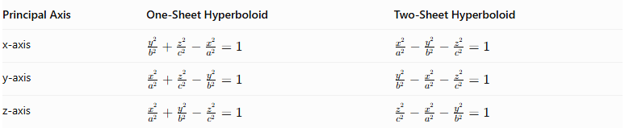
Principal Axis | One-Sheet Hyperboloid | Two-Sheet Hyperboloid
x-axis | $$\frac{y^{2}}{b^{2}}+\frac{z^{2}}{c^{2}}-\frac{x^{2}}{a^{2}}=1$$ | $$\frac{x^{2}}{a^{2}}-\frac{y^{2}}{b^{2}}-\frac{z^{2}}{c^{2}}=1$$
y-axis | $$\frac{x^{2}}{a^{2}}+\frac{z^{2}}{c^{2}}-\frac{y^{2}}{b^{2}}=1$$ | $$\frac{y^{2}}{b^{2}}-\frac{x^{2}}{a^{2}}-\frac{z^{2}}{c^{2}}=1$$
z-axis | $$\frac{x^{2}}{a^{2}}+\frac{y^{2}}{b^{2}}-\frac{z^{2}}{c^{2}}=1$$ | $$\frac{z^{2}}{c^{2}}-\frac{x^{2}}{a^{2}}-\frac{y^{2}}{b^{2}}=1$$

Types According to Cross-Section Shape
# Source: AI Source: Provided by: [Data Path: Persons Table -> ID Column: 1, Name_En Column: Motasem Essam] -> From: [ChatGPT] on [7/25/2026]
Each main type can be further classified according to the relationship between its scale parameters.

Circular Hyperboloid
# Source: AI Source: Provided by: [Data Path: Persons Table -> ID Column: 1, Name_En Column: Motasem Essam] -> From: [ChatGPT] on [7/25/2026]
A circular hyperboloid has equal scale parameters in the two directions perpendicular to its principal axis.
For example:
$$a=b$$
Its horizontal cross-sections perpendicular to the principal axis are circles.
<grid columns={2} gap={3}>
<grid-item>
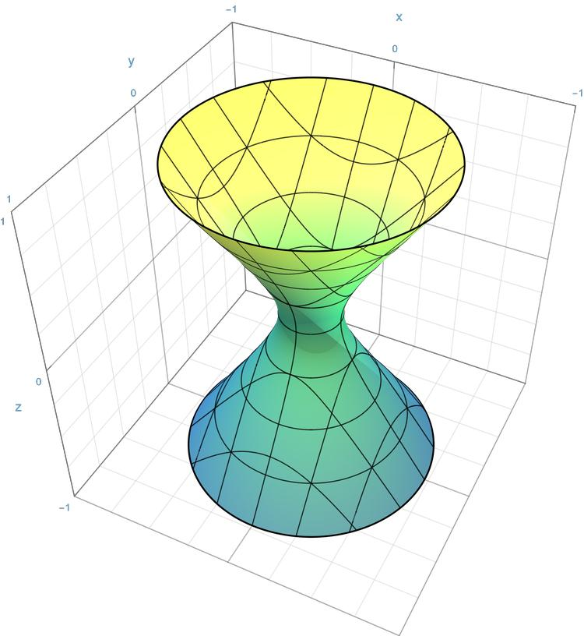
Circular Hyperboloid of One Sheet
</grid-item>
<grid-item>
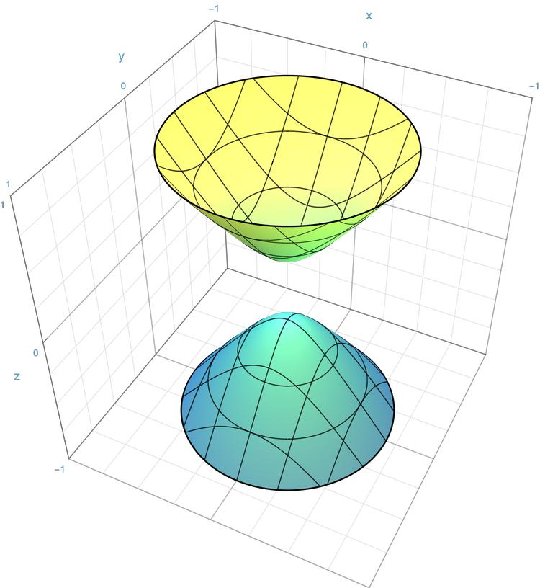
Circular Hyperboloid of Two Sheets
</grid-item>
</grid>

Elliptic Hyperboloid
# Source: AI Source: Provided by: [Data Path: Persons Table -> ID Column: 1, Name_En Column: Motasem Essam] -> From: [ChatGPT] on [7/25/2026]
An elliptic hyperboloid has unequal scale parameters in the two directions perpendicular to its principal axis.
$$a≠b$$
Its perpendicular cross-sections are generally ellipses.
<grid columns={2} gap={3}>
<grid-item>
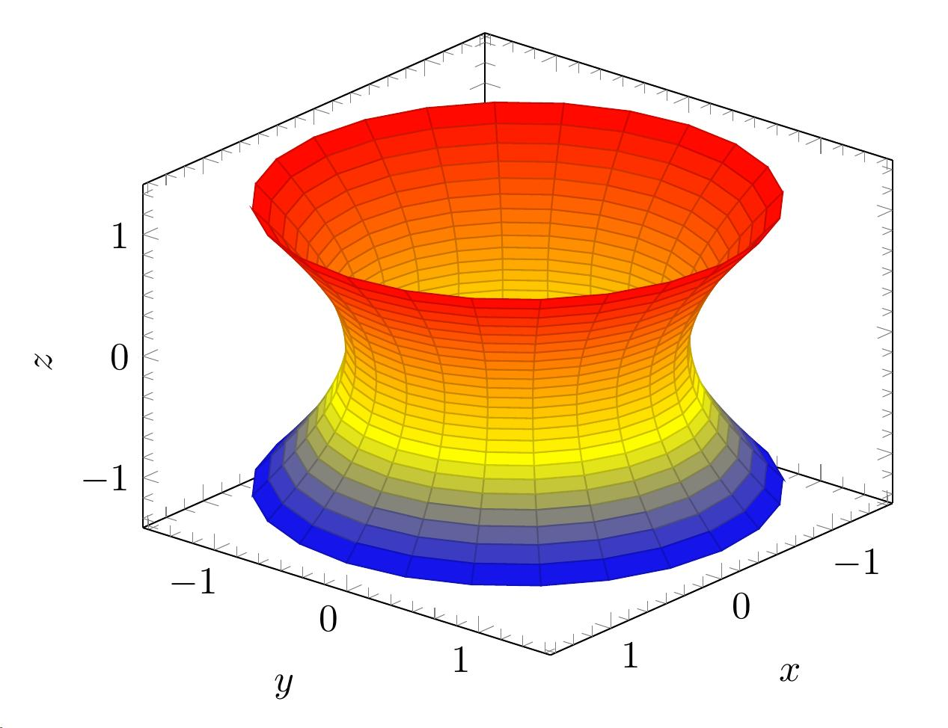
Elliptic Hyperboloid of One Sheet
</grid-item>
<grid-item>
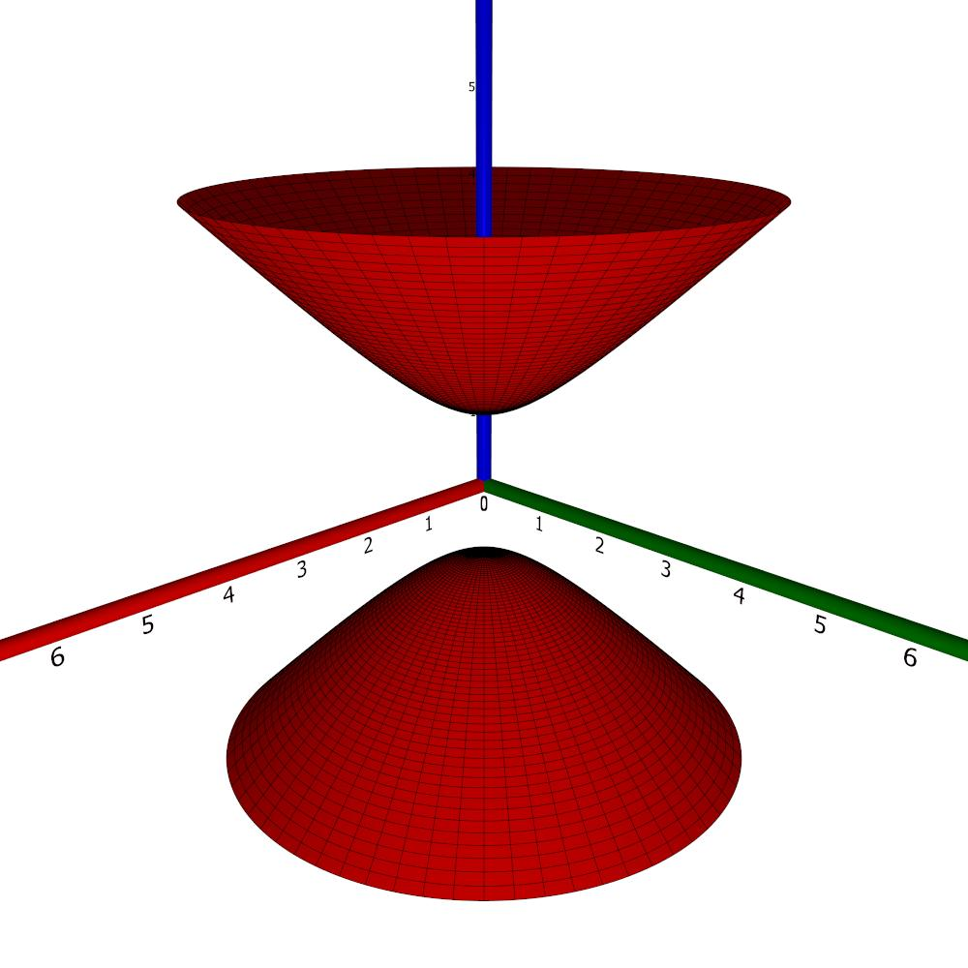
Elliptic Hyperboloid of Two Sheets
</grid-item>
</grid>

Cross-Sections
# Source: AI Source: Provided by: [Data Path: Persons Table -> ID Column: 1, Name_En Column: Motasem Essam] -> From: [ChatGPT] on [7/25/2026]
Cross-sections are formed by intersecting a hyperboloid with planes.

Hyperboloid of One Sheet
# Source: AI Source: Provided by: [Data Path: Persons Table -> ID Column: 1, Name_En Column: Motasem Essam] -> From: [ChatGPT] on [7/25/2026]
For the standard equation:
$$\frac{x^{2}}{a^{2}}+\frac{y^{2}}{b^{2}}-\frac{z^{2}}{c^{2}}=1$$
Horizontal cross-sections
Set $z=t$:
$$\frac{x^{2}}{a^{2}}+\frac{y^{2}}{b^{2}}=1+\frac{t^{2}}{c^{2}}$$
The result is always an ellipse.
When $a=b$, the section is a circle.
At $z=0$, the section is the smallest ellipse, called the waist.
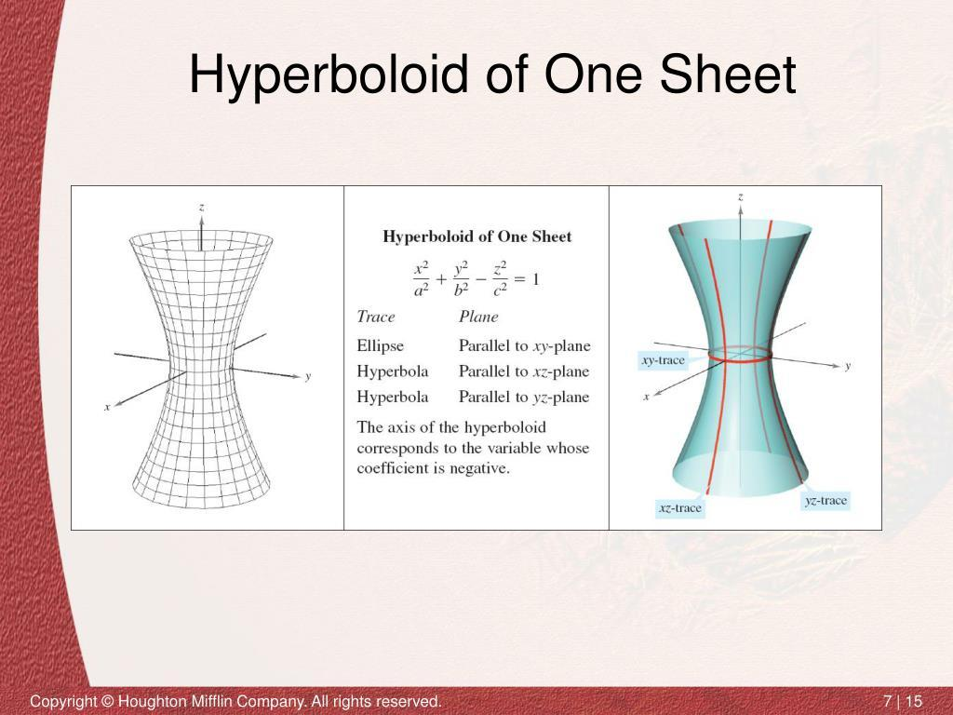
Vertical cross-sections
- Plane $x=0$: hyperbola.
- Plane $y=0$: hyperbola.
- Other vertical planes parallel to the principal axis: generally hyperbolas.
Diagonal cross-sections
Certain oblique planes intersect the surface in hyperbolas or, in special cases, pairs of straight lines.

Hyperboloid of Two Sheets
# Source: AI Source: Provided by: [Data Path: Persons Table -> ID Column: 1, Name_En Column: Motasem Essam] -> From: [ChatGPT] on [7/25/2026]
For the standard equation:
$$\frac{z^{2}}{c^{2}}-\frac{x^{2}}{a^{2}}-\frac{y^{2}}{b^{2}}=1$$
Horizontal cross-sections
Set $z=t$:
$$\frac{x^{2}}{a^{2}}+\frac{y^{2}}{b^{2}}=\frac{t^{2}}{c^{2}}-1$$
The result depends on the value of $t$.
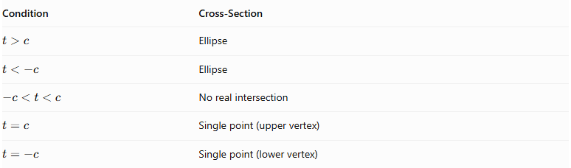
Condition | Cross-Section
$$t>c$$ | Ellipse
$$t<-c$$ | Ellipse
$$-c<t<c$$ | No real intersection
$$t=c$$ | Single point (upper vertex)
$$t=-c$$ | Single point (lower vertex)
Vertical cross-sections
Planes passing through the principal axis produce hyperbolas.
For example, set $y=0$:
$$\frac{z^{2}}{c^{2}}-\frac{x^{2}}{a^{2}}=1$$
This is a hyperbola.

Mathematical Properties and Formulas

Center
# Source: AI Source: Provided by: [Data Path: Persons Table -> ID Column: 1, Name_En Column: Motasem Essam] -> From: [ChatGPT] on [7/25/2026]
For both standard forms:
$$\boxed{C=(0,0,0)}$$

Waist of a One-Sheet Hyperboloid
# Source: AI Source: Provided by: [Data Path: Persons Table -> ID Column: 1, Name_En Column: Motasem Essam] -> From: [ChatGPT] on [7/25/2026]
For the standard one-sheet equation, the waist occurs at:
$$z=0$$
Its semi-axis lengths are:
$$a, b$$
Its area is:
$$\boxed{A=πab}$$
For the circular case, where $a=b$:
$$A=πa^{2}$$

Vertices of a Two-Sheet Hyperboloid
# Source: AI Source: Provided by: [Data Path: Persons Table -> ID Column: 1, Name_En Column: Motasem Essam] -> From: [ChatGPT] on [7/25/2026]
$$\boxed{V_{1}=(0,0,c)}$$
$$\boxed{V_{2}=(0,0,-c)}$$

Volume
# Source: AI Source: Provided by: [Data Path: Persons Table -> ID Column: 1, Name_En Column: Motasem Essam] -> From: [ChatGPT] on [7/25/2026]
A complete hyperboloid is unbounded and therefore has infinite volume if considered as a three-dimensional region. The surface itself encloses no finite interior volume.
A bounded portion can have a finite volume if it is enclosed by suitable cutting planes and boundary surfaces.

Surface Area
# Source: AI Source: Provided by: [Data Path: Persons Table -> ID Column: 1, Name_En Column: Motasem Essam] -> From: [ChatGPT] on [7/25/2026]
The complete hyperboloid has infinite surface area because it extends indefinitely.
The surface area of a bounded portion depends on the selected limits and dimensions.

Worked Examples

Example 1: Identify the Type of Hyperboloid
# Source: AI Source: Provided by: [Data Path: Persons Table -> ID Column: 1, Name_En Column: Motasem Essam] -> From: [ChatGPT] on [7/25/2026]
Given:
$$\frac{x^{2}}{25}+\frac{y^{2}}{9}-\frac{z^{2}}{16}=1$$
Determine the type, center, and principal axis.
Solution:
The equation has two positive squared terms and one negative squared term.
Therefore, it is a Hyperboloid of One Sheet.
The negative term is associated with $z^{2}$, so its principal axis is the z-axis.
Its center is:
$$\boxed{C=(0,0,0)}$$
The waist semi-axis lengths are:
$$a=5, b=3$$
The waist area is:
$$A=π(5)(3)$$
$$\boxed{A=15π≈47.12}$$

Example 2: Identify the Vertices
# Source: AI Source: Provided by: [Data Path: Persons Table -> ID Column: 1, Name_En Column: Motasem Essam] -> From: [ChatGPT] on [7/25/2026]
Given:
$$\frac{z^{2}}{36}-\frac{x^{2}}{16}-\frac{y^{2}}{25}=1$$
Determine the type, principal axis, and vertices.
Solution:
There is one positive squared term and two negative squared terms.
Therefore, it is a Hyperboloid of Two Sheets.
The positive term is associated with $z^{2}$, so its principal axis is the z-axis.
Since:
$$c^{2}=36$$
$$c=6$$
The vertices are:
$$V_{1}=(0,0,6)$$
$$V_{2}=(0,0,-6)$$
$$\boxed{V_{1}=(0,0,6), V_{2}=(0,0,-6)}$$

Constructing a Hyperboloid

Geometric Instruments
# Source: AI Source: Provided by: [Data Path: Persons Table -> ID Column: 1, Name_En Column: Motasem Essam] -> From: [ChatGPT] on [7/25/2026]
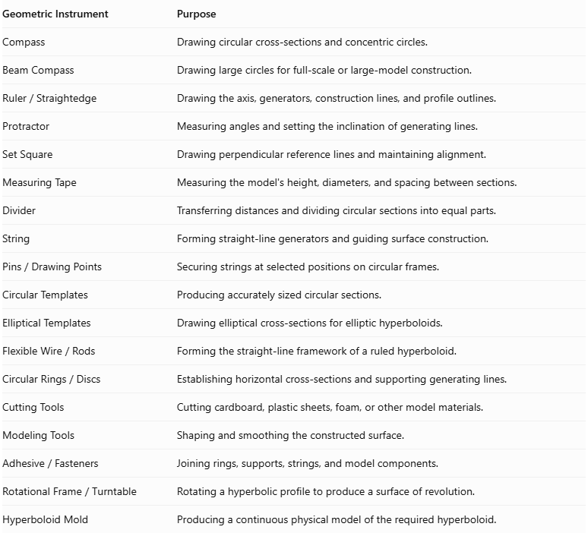
Geometric Instrument | Purpose
Compass | Drawing circular cross-sections and concentric circles.
Beam Compass | Drawing large circles for full-scale or large-model construction.
$$Ruler/Straightedge$$ | Drawing the axis, generators, construction lines, and profile outlines.
Protractor | Measuring angles and setting the inclination of generating lines.
Set Square | Drawing perpendicular reference lines and maintaining alignment.
Measuring Tape | Measuring the model's height, diameters, and spacing between sections.
Divider | Transferring distances and dividing circular sections into equal parts.
String | Forming straight-line generators and guiding surface construction.
$$Pins/DrawingPoints$$ | Securing strings at selected positions on circular frames.
Circular Templates | Producing accurately sized circular sections.
Elliptical Templates | Drawing elliptical cross-sections for elliptic hyperboloids.
$$FlexibleWire/Rods$$ | Forming the straight-line framework of a ruled hyperboloid.
$$CircularRings/Discs$$ | Establishing horizontal cross-sections and supporting generating lines.
Cutting Tools | Cutting cardboard, plastic sheets, foam, or other model materials.
Modeling Tools | Shaping and smoothing the constructed surface.
$$Adhesive/Fasteners$$ | Joining rings, supports, strings, and model components.
$$RotationalFrame/Turntable$$ | Rotating a hyperbolic profile to produce a surface of revolution.
Hyperboloid Mold | Producing a continuous physical model of the required hyperboloid.
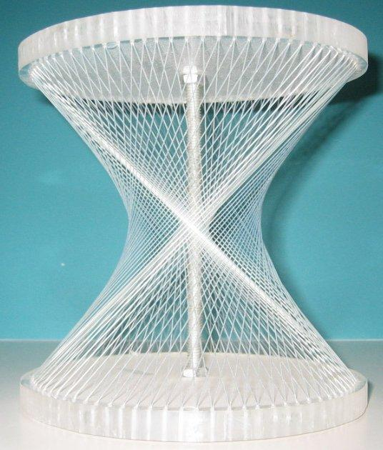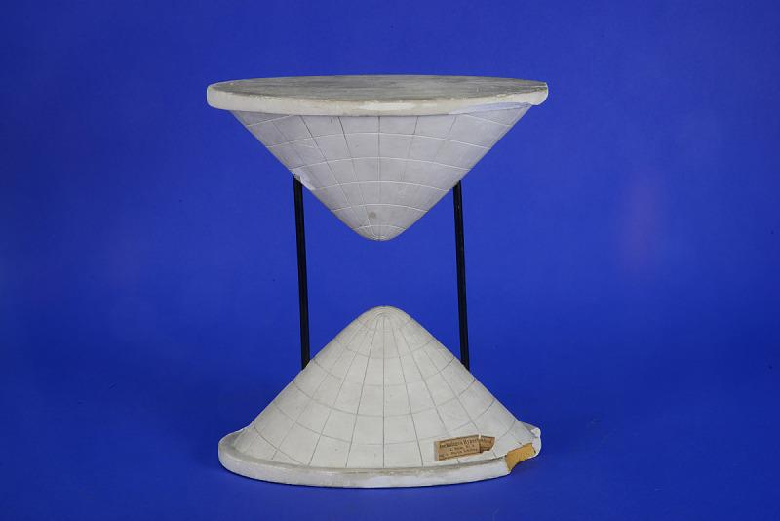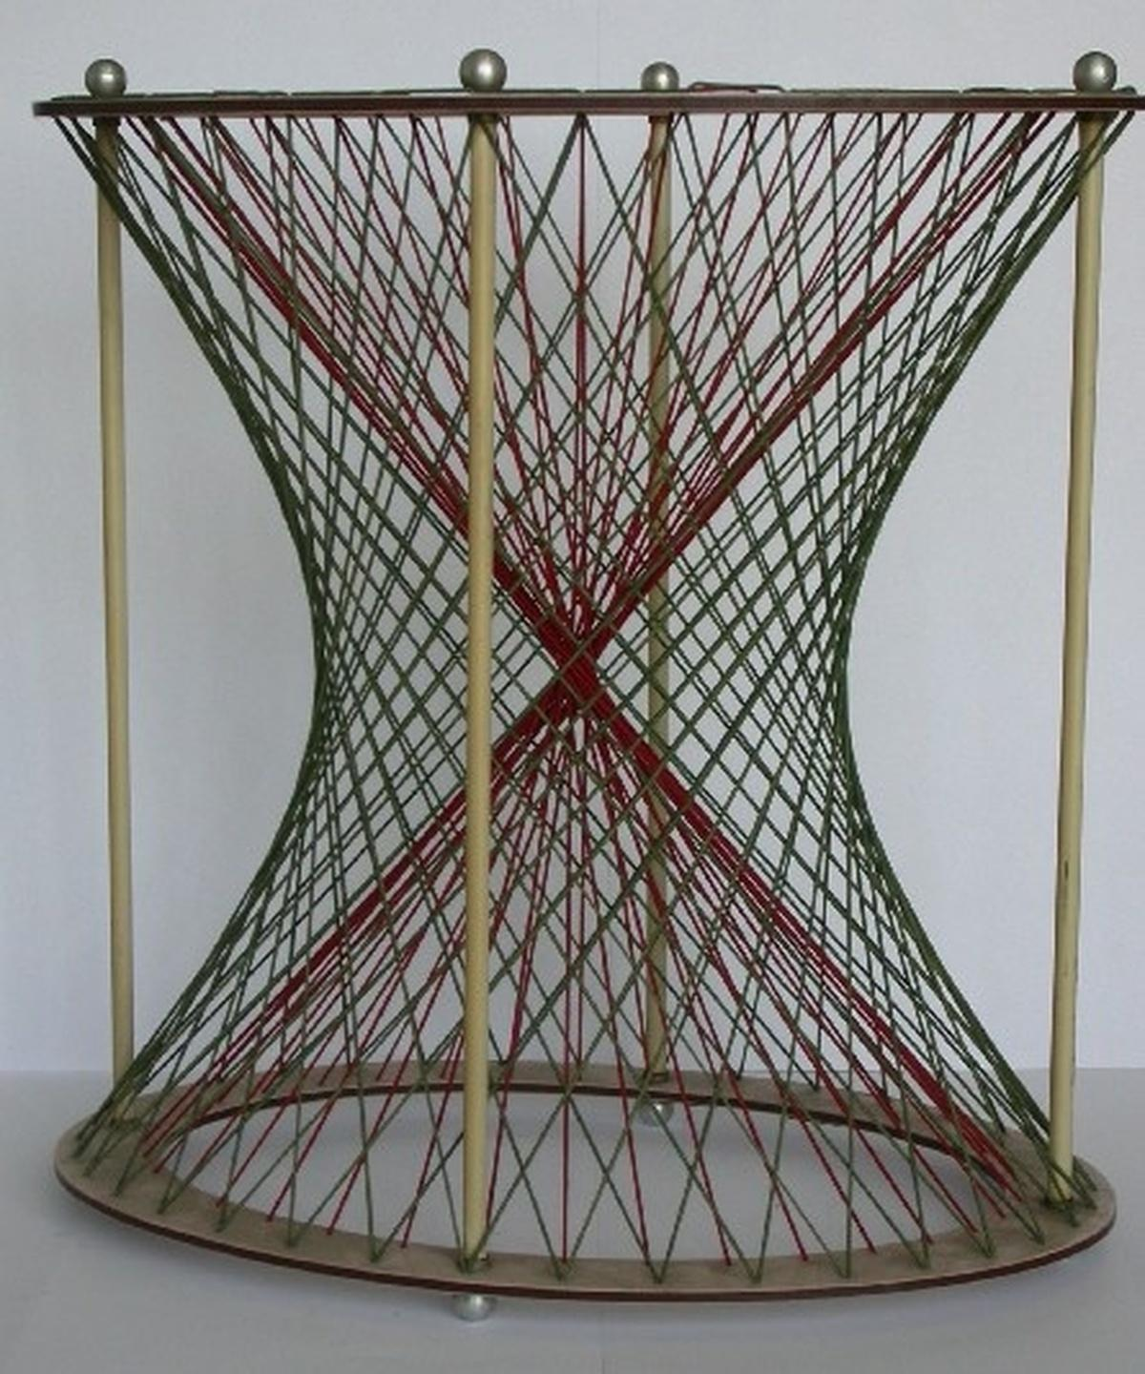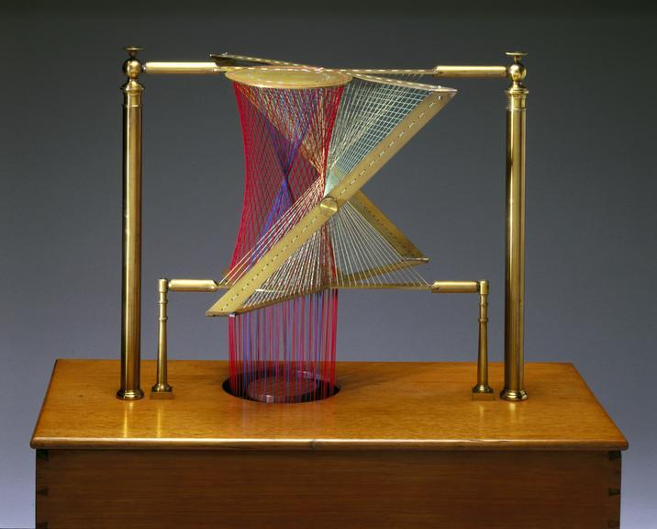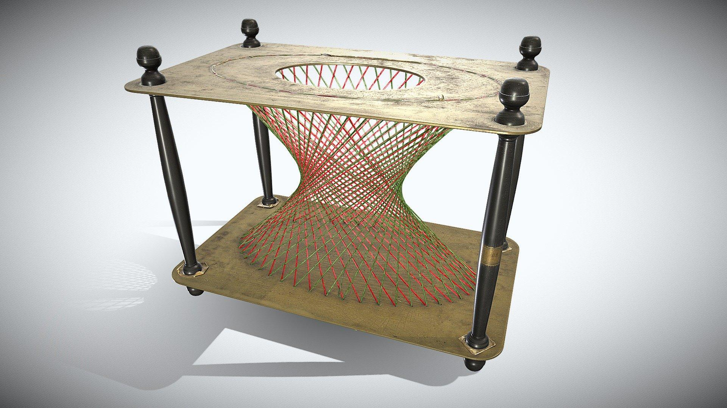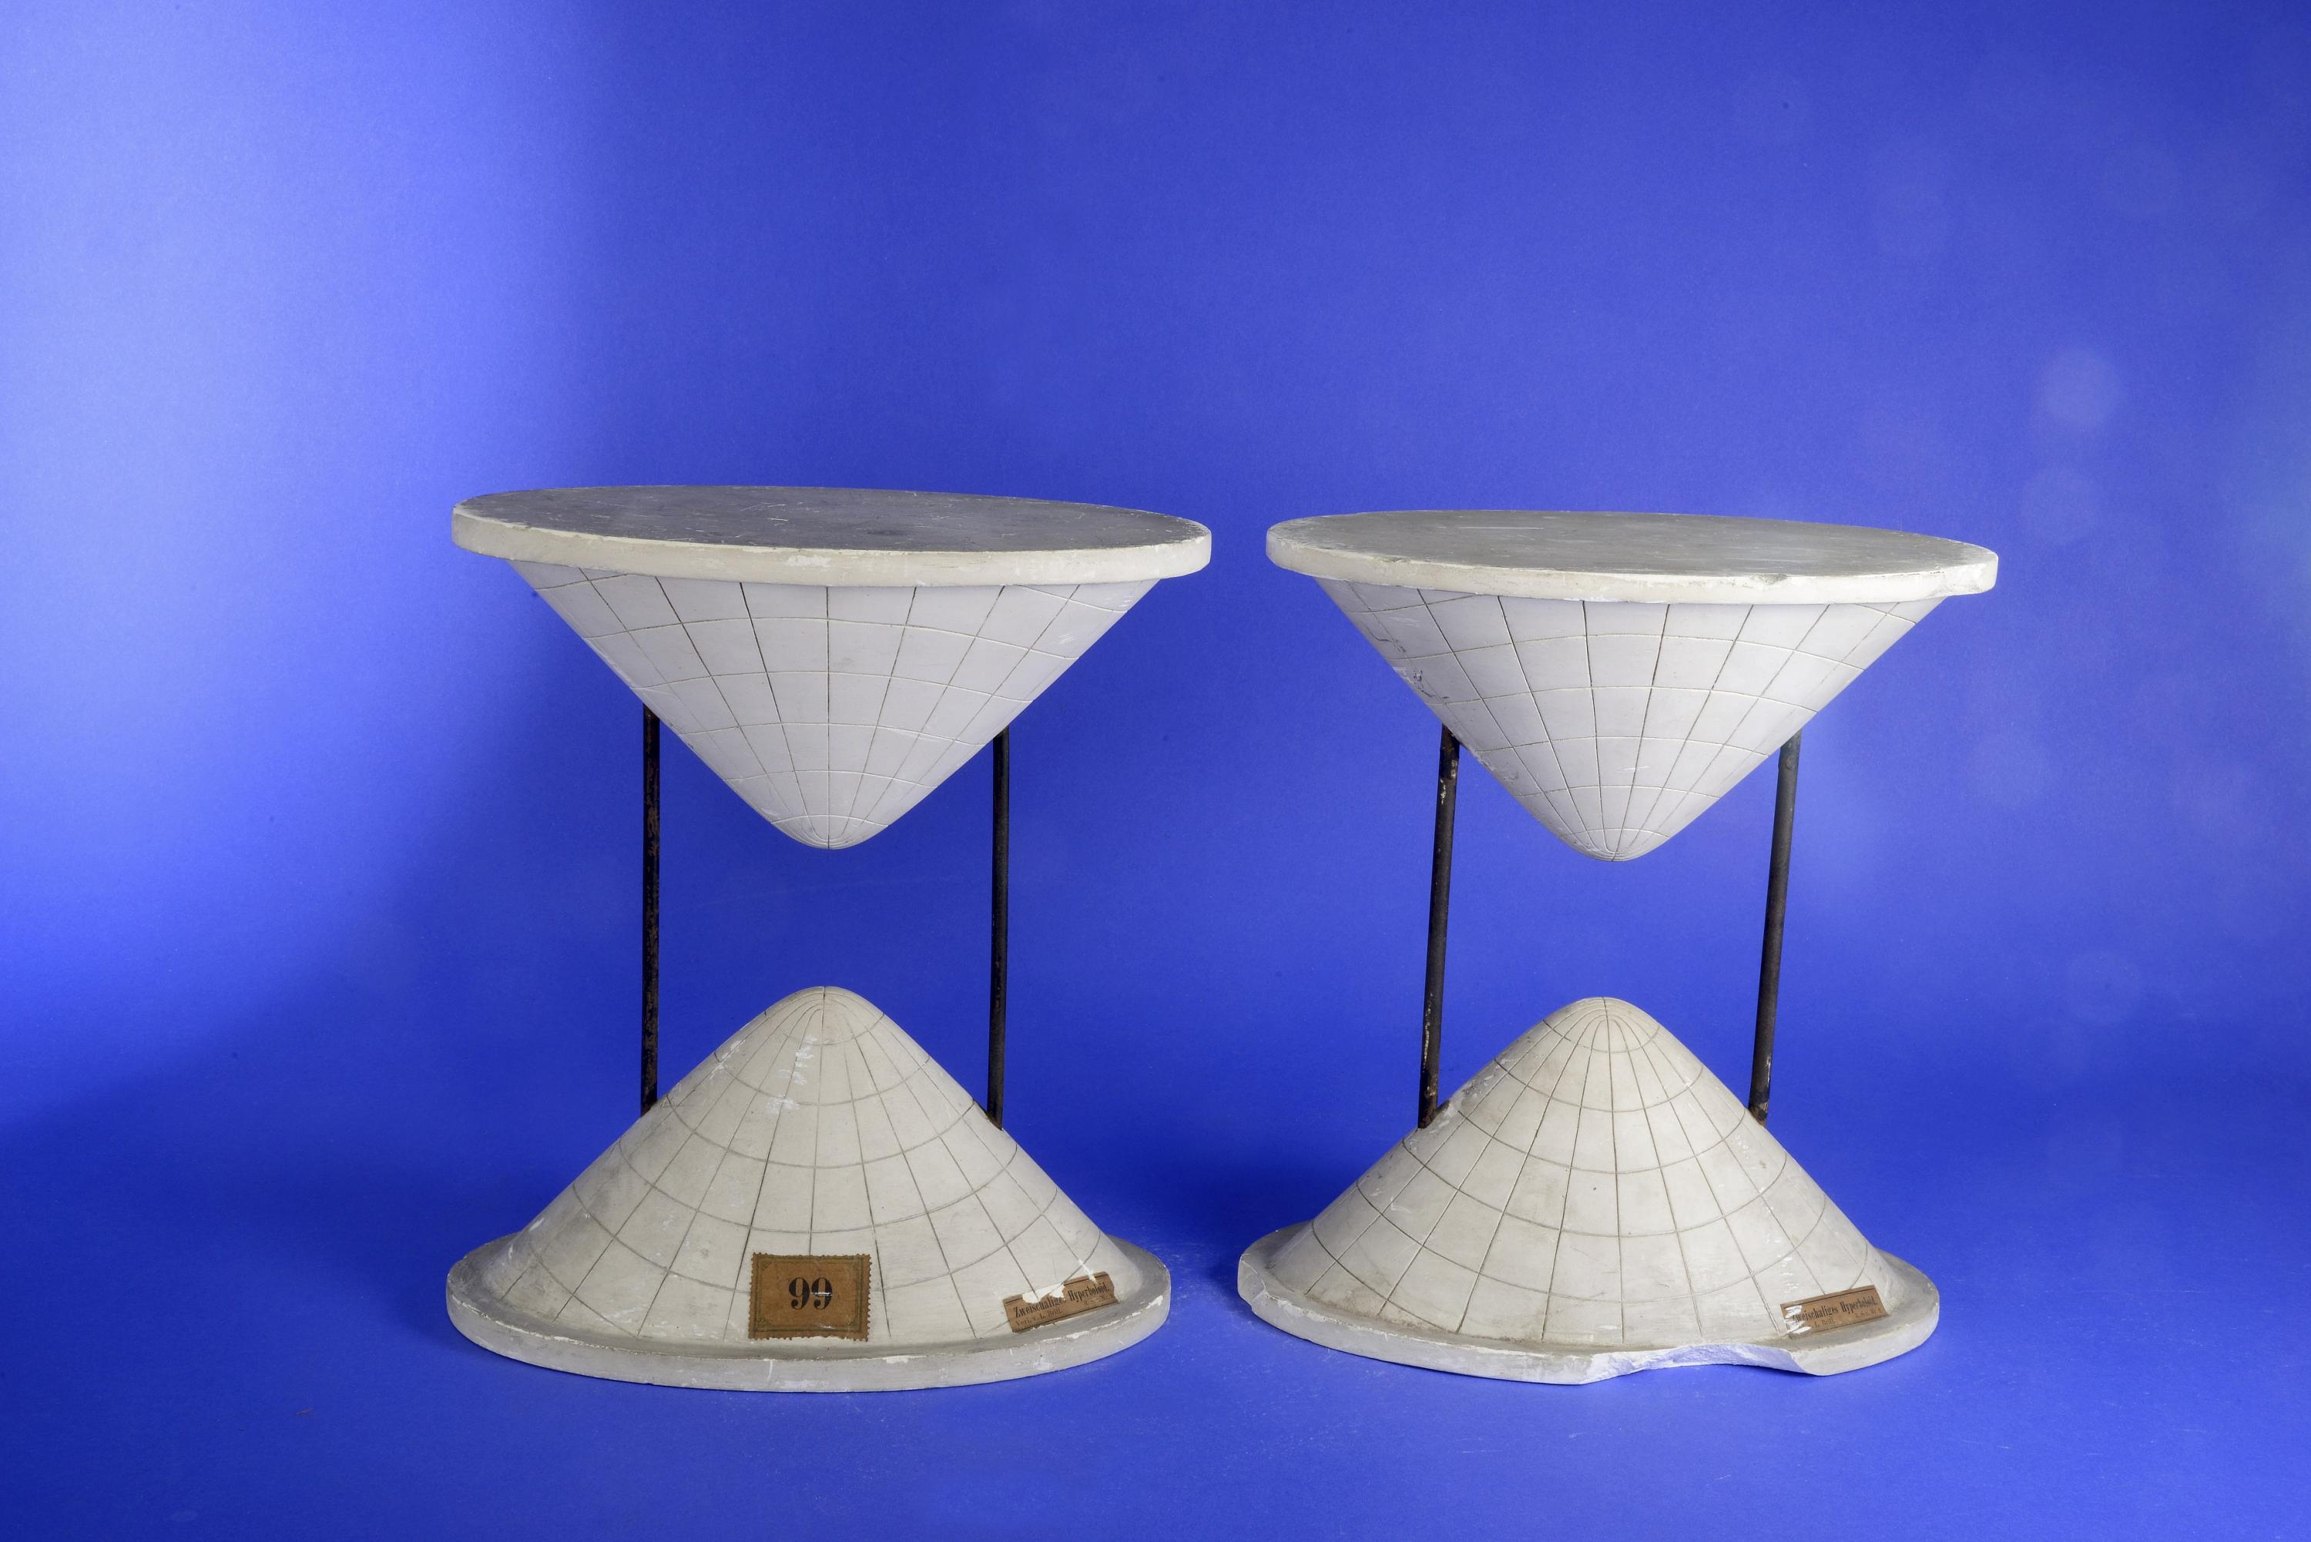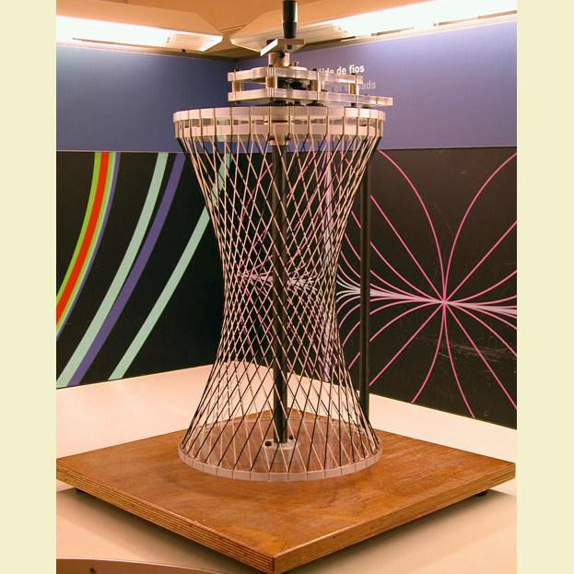

Instrument-Based Construction Procedures

Construction Using Straight-Line Generators (One-Sheet Hyperboloid)
# Source: AI Source: Provided by: [Data Path: Persons Table -> ID Column: 1, Name_En Column: Motasem Essam] -> From: [ChatGPT] on [7/25/2026]
- Prepare two circular rings of equal or different diameters, depending on the intended proportions.
- Mark corresponding division points around both rings using a compass, divider, and ruler.
- Position the rings horizontally, one above the other, with their centers aligned along a common vertical axis.
- Rotate the upper ring relative to the lower ring by a selected angle.
- Stretch straight strings or thin wires between carefully selected points on the two rings.
- Arrange the strings so that they form the two families of intersecting straight-line generators.
- Secure each string at both ends using pins, adhesive, or small fasteners.
- Add additional generators around the rings to create a denser surface framework.
- Check the symmetry and smooth hourglass-shaped outline of the completed model.
This method constructs a one-sheet hyperboloid, which is a doubly ruled surface: it contains two distinct families of straight-line generators.

Construction Using an Adjustable Ring-and-String Framework
# Source: AI Source: Provided by: [Data Path: Persons Table -> ID Column: 1, Name_En Column: Motasem Essam] -> From: [ChatGPT] on [7/25/2026]
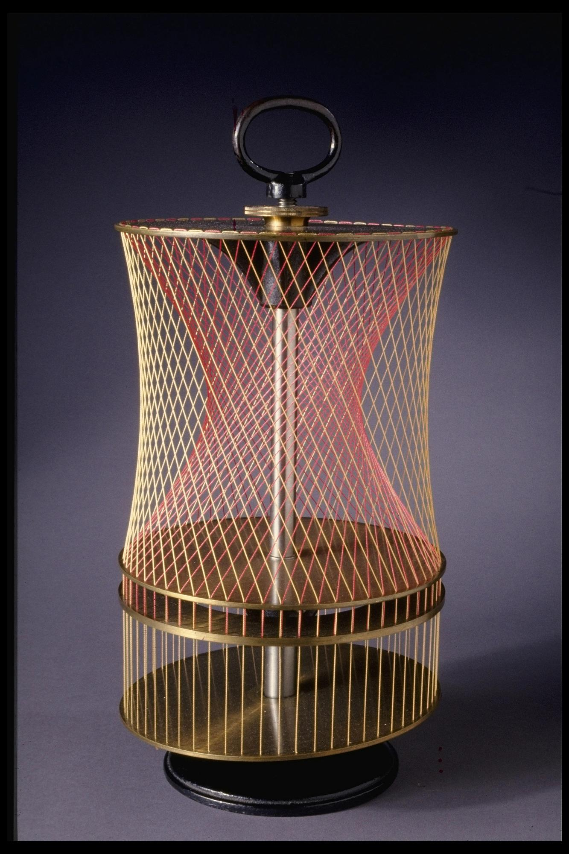
- Prepare a stable base with a central vertical spindle.
- Attach several circular discs or rings around the spindle.
- Drill or mark equally spaced holes around the circumference of each ring.
- Fix the lower and upper rings in position.
- Allow the middle ring to rotate around the central spindle.
- Pass strings through corresponding holes in the rings.
- Rotate the middle ring until the strings form the curved hyperboloid framework.
- Adjust the strings to create a continuous hourglass-shaped surface.
- Secure the strings and inspect the resulting structure.
An adjustable framework can demonstrate the transformation between different ruled surfaces, including a cylinder, a double cone, and a one-sheet hyperboloid, depending on its configuration.

Construction by Rotating a Hyperbolic Profile
# Source: AI Source: Provided by: [Data Path: Persons Table -> ID Column: 1, Name_En Column: Motasem Essam] -> From: [ChatGPT] on [7/25/2026]
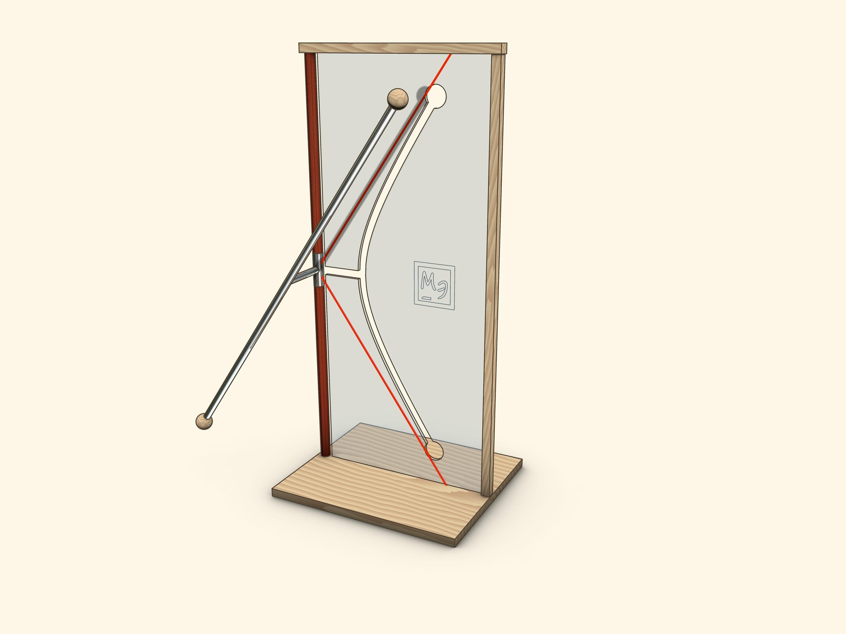
- Draw a vertical axis using a ruler and set square.
- Construct a hyperbola on a vertical drawing sheet using a suitable geometric hyperbola construction method.
- Mark the vertex and several points along one branch of the hyperbola.
- Cut out the profile or transfer its outline to a thin rigid material.
- Attach the profile to a rotational frame with its axis of symmetry aligned with the rotation axis.
- Rotate the profile through a complete revolution of ${360}^{°}$.
- Use the resulting rotational outline as a guide for shaping clay, foam, plaster, or another modeling material.
- Smooth the surface while maintaining the hyperbolic profile.
- Check the symmetry and circular cross-sections of the finished model.
Rotating a hyperbola around its conjugate axis produces a hyperboloid of revolution. The profile and axis selected determine the particular form.

Construction Using Circular Cross-Sections
# Source: AI Source: Provided by: [Data Path: Persons Table -> ID Column: 1, Name_En Column: Motasem Essam] -> From: [ChatGPT] on [7/25/2026]
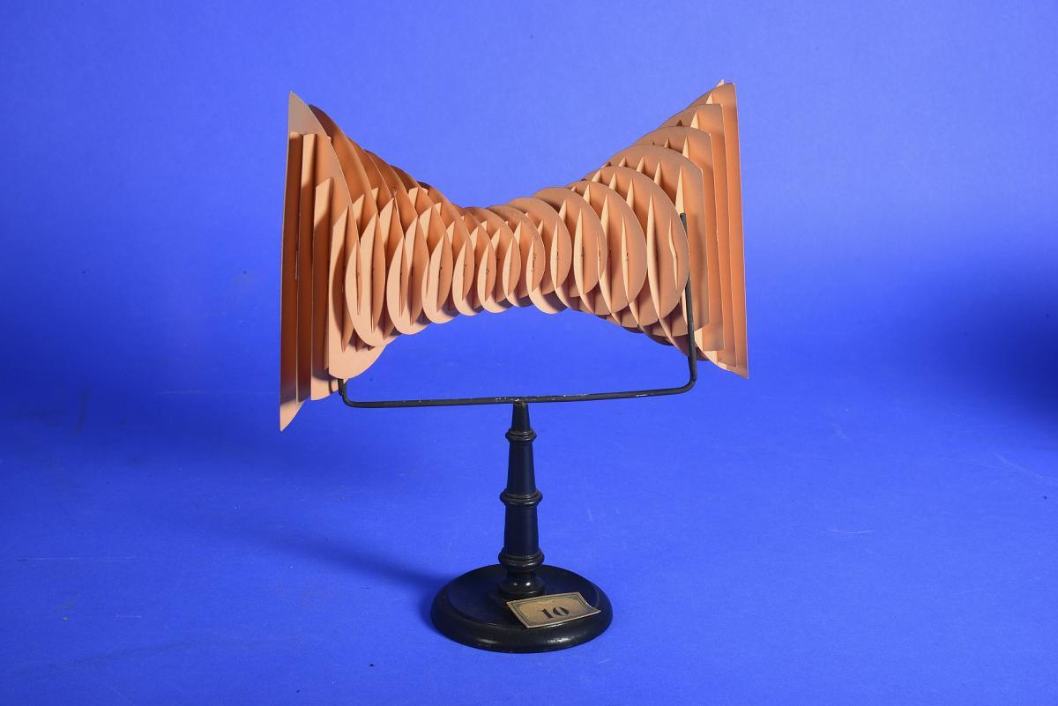
- Draw a vertical centerline representing the principal axis.
- Mark several horizontal levels along the centerline.
- Determine the required radius at each level using a measuring tape or compass.
- Draw circular templates for the corresponding cross-sections.
- Cut the circles from cardboard, foam, or thin plastic sheets.
- Place the circular sections horizontally at their designated heights.
- Connect the edges of successive sections using flexible strips, wires, or modeling material.
- Adjust the connecting material to create the characteristic narrow waist and outward-flaring upper and lower portions.
- Smooth the surface to create a continuous hyperboloid model.
For a circular one-sheet hyperboloid, the radius is smallest at the central waist and increases toward both ends. This sectional method gives an approximation whose smoothness depends on the number of sections used.

Construction of a Two-Sheet Hyperboloid Using Separate Surface Sections
# Source: AI Source: Provided by: [Data Path: Persons Table -> ID Column: 1, Name_En Column: Motasem Essam] -> From: [ChatGPT] on [7/25/2026]
- Draw the principal axis using a ruler.
- Mark two separate regions on opposite sides of the central reference plane.
- Construct the upper and lower hyperbolic profiles using geometric drawing instruments.
- Prepare circular or elliptical templates for the required cross-sections.
- Cut the cross-sections from cardboard, foam, or plastic.
- Arrange the sections separately along the principal axis.
- Connect the corresponding sections using thin strips, flexible wire, or modeling material.
- Shape each part so that its cross-sections become larger away from its vertex.
- Keep the two surface components physically separated.
- Mount both components on a common support if a complete educational model is required.
The result is a hyperboloid of two sheets, consisting of two disconnected surface components. Its parallel sections perpendicular to the principal axis are elliptical where real sections exist.

Construction Using a Wire-Frame Model
# Source: AI Source: Provided by: [Data Path: Persons Table -> ID Column: 1, Name_En Column: Motasem Essam] -> From: [ChatGPT] on [7/25/2026]
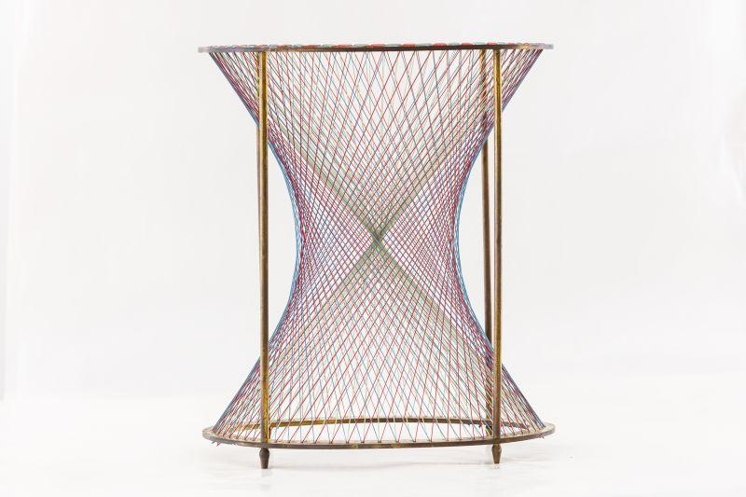
- Prepare a circular base and an upper circular support.
- Mark equally spaced attachment points around both supports.
- Cut several lengths of flexible wire or thin metal rods.
- Bend and position the wires between selected points on the upper and lower supports.
- Arrange the wires in inclined directions to create the hyperboloid's ruled framework.
- Add a second family of inclined wires where the model design permits.
- Secure all connections using fasteners or adhesive.
- Adjust the wire positions to produce a symmetrical waist and outward-flaring ends.
- Add additional wires to increase the density of the framework.
This method is particularly suitable for demonstrating the ruled-surface structure of a one-sheet hyperboloid.

Construction Using a Mold
# Source: AI Source: Provided by: [Data Path: Persons Table -> ID Column: 1, Name_En Column: Motasem Essam] -> From: [ChatGPT] on [7/25/2026]
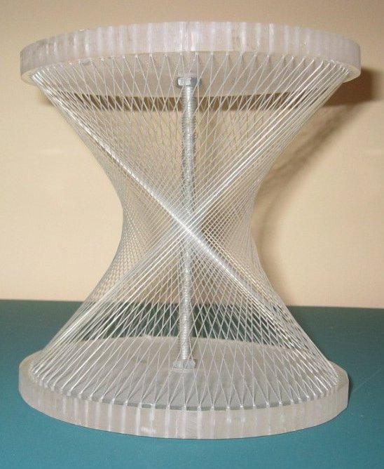
- Select the required hyperboloid type and dimensions.
- Prepare a mold with the appropriate hyperbolic inner or outer profile.
- Verify the symmetry and dimensions using a ruler, compass, and measuring tape.
- Apply a suitable release material to the mold if required.
- Pour plaster, resin, or another modeling material into the mold.
- Allow the material to set or cure completely.
- Remove the formed model carefully.
- Trim excess material and smooth the surface.
- Check the finished model against the intended profile and dimensions.
A mold is suitable for producing a continuous solid model, but the mold must be designed specifically for the selected hyperboloid.

Construction Using a Paper or Cardboard Model
# Source: AI Source: Provided by: [Data Path: Persons Table -> ID Column: 1, Name_En Column: Motasem Essam] -> From: [ChatGPT] on [7/25/2026]
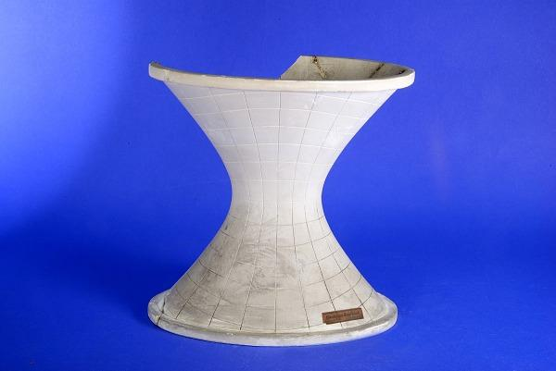
- Draw the required hyperbolic profile on paper or thin cardboard.
- Mark the surface boundaries and the intended dimensions.
- Divide the profile into suitable construction sections.
- Cut the required pieces carefully using cutting tools.
- Fold or curve the pieces according to the intended surface shape.
- Join the sections using adhesive or small fasteners.
- Attach the completed model to a supporting base.
- Adjust the pieces to obtain the required hyperboloid shape.
- Allow the adhesive to dry and inspect the final model.
This method is useful for educational demonstrations and simplified physical representations. A paper model may approximate the surface rather than reproduce its exact continuous geometry.
Construction Note: These procedures use physical geometric instruments, straight-line generators, profiles, templates, rotational mechanisms, and molds. They do not use coordinate-based construction. The straight-line generator and adjustable ring methods are especially appropriate for constructing a one-sheet hyperboloid, while the separate-section method is appropriate for a two-sheet hyperboloid.

Important Characteristics
# Source: AI Source: Provided by: [Data Path: Persons Table -> ID Column: 1, Name_En Column: Motasem Essam] -> From: [ChatGPT] on [7/25/2026]
- A hyperboloid is a three-dimensional quadric surface.
- It has two main types: one-sheet and two-sheet.
- A one-sheet hyperboloid is one connected surface.
- A two-sheet hyperboloid consists of two separate connected surfaces.
- The principal axis is determined by the squared term with the unique sign.
- A one-sheet hyperboloid has a waist at its central cross-section.
- A two-sheet hyperboloid has two vertices along its principal axis.
- Both types are ruled surfaces and contain straight-line generators.
- Circular hyperboloids have rotational symmetry about their principal axis.
- Elliptic hyperboloids generally do not have continuous rotational symmetry.
- Their horizontal and vertical cross-sections produce ellipses and hyperbolas, depending on the type and cutting plane.

Comparison Between the Two Types
# Source: AI Source: Provided by: [Data Path: Persons Table -> ID Column: 1, Name_En Column: Motasem Essam] -> From: [ChatGPT] on [7/25/2026]
<grid columns={2} gap={3}>
<grid-item>
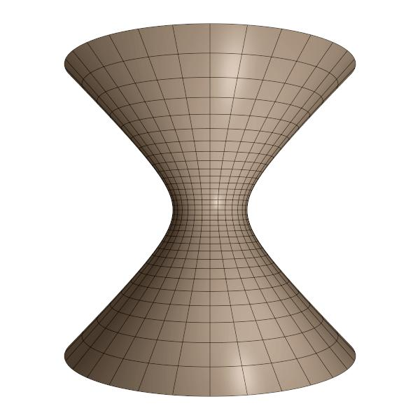
One-Sheet Hyperboloid
</grid-item>
<grid-item>
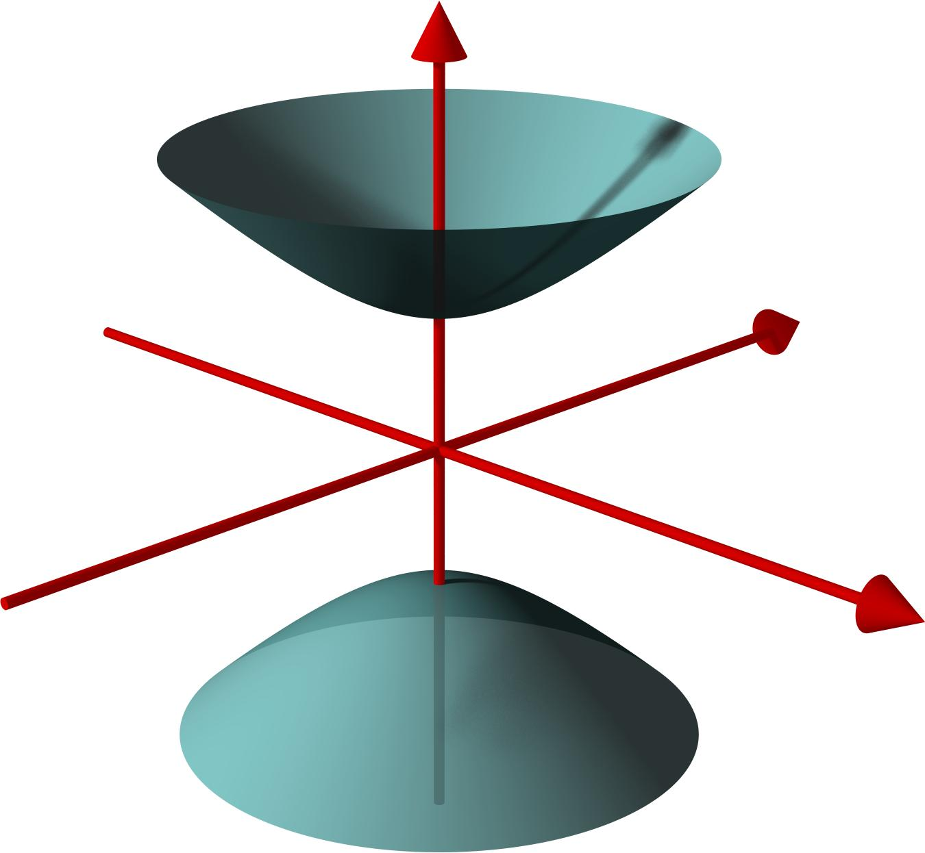
Two-Sheet Hyperboloid
</grid-item>
</grid>
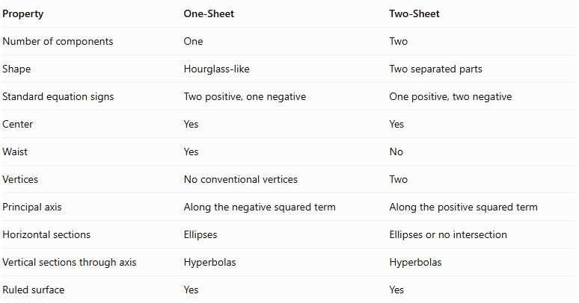
Property | One-Sheet | Two-Sheet
Number of components | One | Two
Shape | Hourglass-like | Two separated parts
Standard equation signs | Two positive, one negative | One positive, two negative
Center | Yes | Yes
Waist | Yes | No
Vertices | No conventional vertices | Two
Principal axis | Along the negative squared term | Along the positive squared term
Horizontal sections | Ellipses | Ellipses or no intersection
Vertical sections through axis | Hyperbolas | Hyperbolas
Ruled surface | Yes | Yes

Applications
# Source: AI Source: Provided by: [Data Path: Persons Table -> ID Column: 1, Name_En Column: Motasem Essam] -> From: [ChatGPT] on [7/25/2026]
<grid columns={2} gap={3}>
<grid-item>
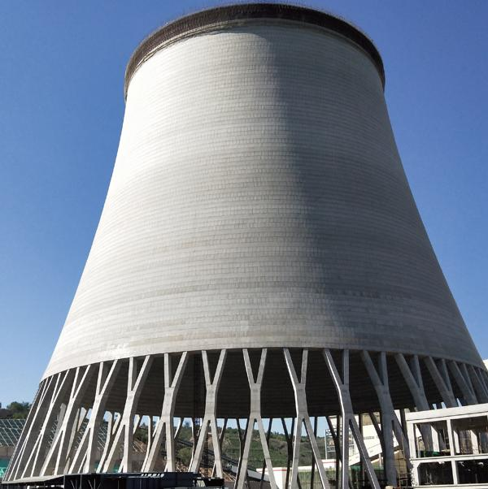
Cooling Towers
Hyperboloid-shaped structures are widely used in industrial cooling towers.
</grid-item>
<grid-item>

Architecture
Used in structural designs and distinctive building forms.
</grid-item>
<grid-item>
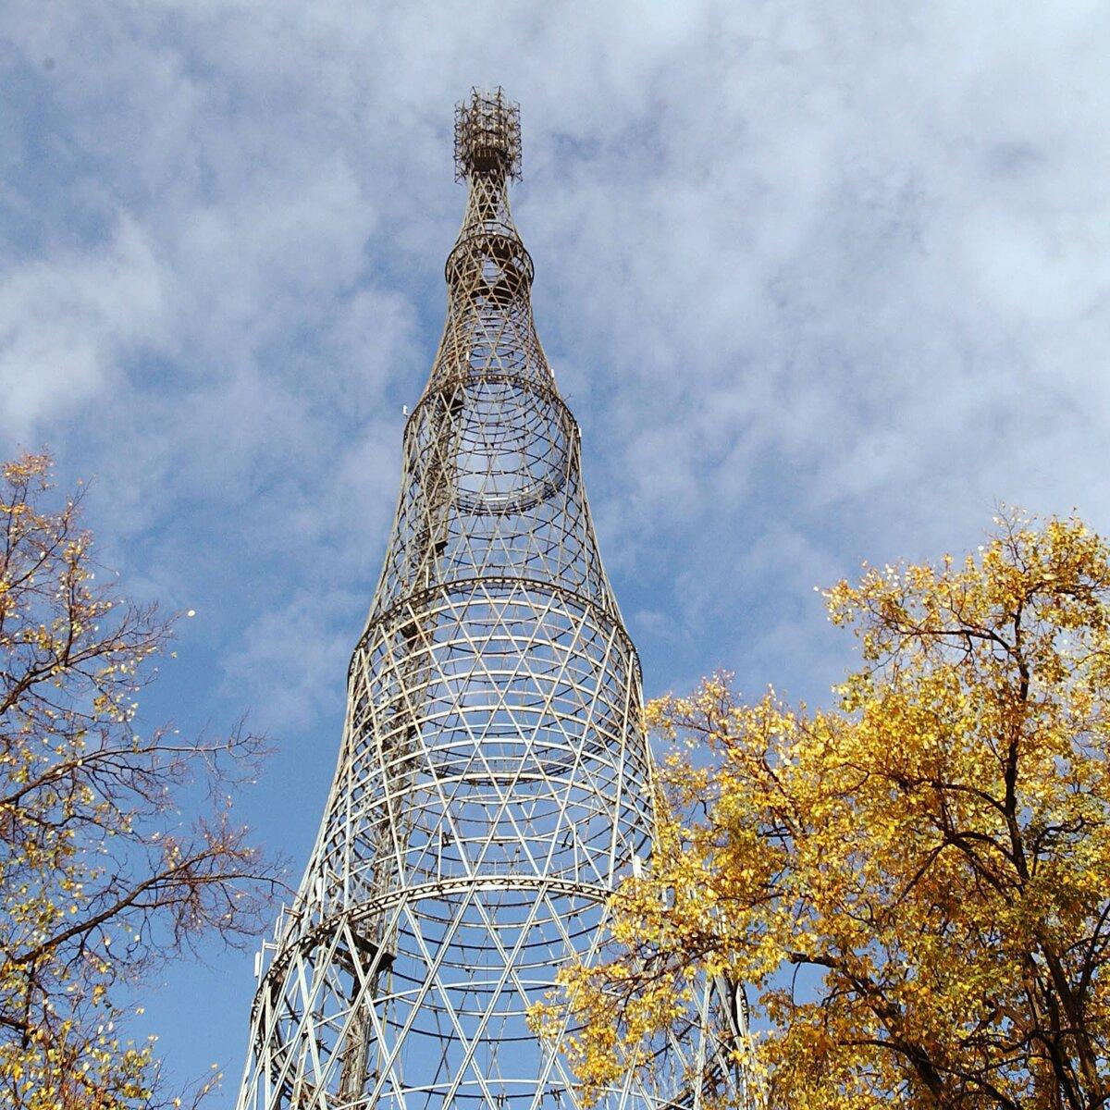
Engineering Structures
Used in lattice towers and lightweight frameworks.
</grid-item>
<grid-item>
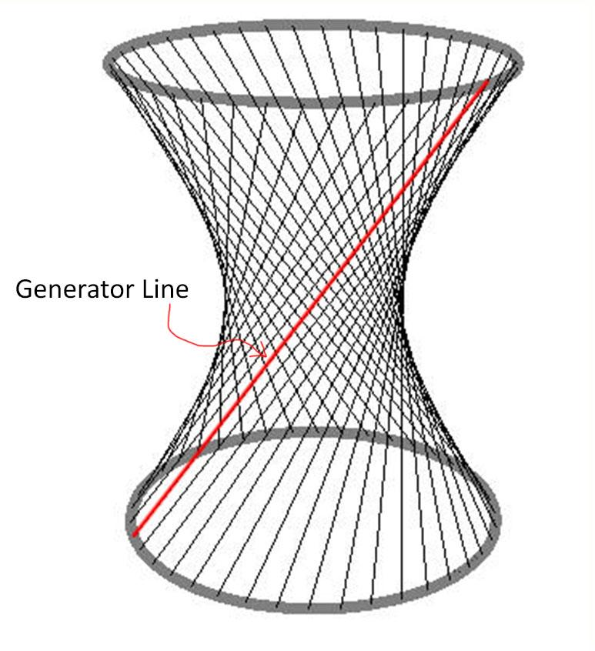
Geometric Construction
Used in mathematical models and ruled-surface construction.
</grid-item>
</grid>

Key Points
# Source: AI Source: Provided by: [Data Path: Persons Table -> ID Column: 1, Name_En Column: Motasem Essam] -> From: [ChatGPT] on [7/25/2026]
- A hyperboloid is a three-dimensional quadric surface.
- It has two main types:
- Hyperboloid of One Sheet.
- Hyperboloid of Two Sheets.
- The one-sheet type has one connected surface and a waist.
- The two-sheet type has two separate surfaces and two vertices.
- Both types are ruled surfaces.
- Their standard equations are:
One Sheet:
$$\boxed{\frac{x^{2}}{a^{2}}+\frac{y^{2}}{b^{2}}-\frac{z^{2}}{c^{2}}=1}$$
Two Sheets:
$$\boxed{\frac{z^{2}}{c^{2}}-\frac{x^{2}}{a^{2}}-\frac{y^{2}}{b^{2}}=1}$$

Conclusion
# Source: AI Source: Provided by: [Data Path: Persons Table -> ID Column: 1, Name_En Column: Motasem Essam] -> From: [ChatGPT] on [7/25/2026]
The Hyperboloid is an important three-dimensional geometric surface classified into one-sheet and two-sheet forms. Its distinctive properties include its principal axis, center, waist or vertices, and curved cross-sections.
It is particularly important in solid geometry, analytical geometry, architecture, and structural engineering because of its mathematical properties and its ability to be constructed using straight-line generators.

